**Project Design Phase-II**

**Technology Stack (Architecture & Stack)**

|  |  |
| --- | --- |
| Date | 13 October 2022 |
| Team ID | PNT2022TMID07118 |
| Project Name | Project - A Gesture-based Tool for Sterile Browsing of Radiology Images |
| Maximum Marks | 4 Marks |

**Technical Architecture:**

The Deliverable shall include the architectural diagram as below and the information as per the table1 & table 2

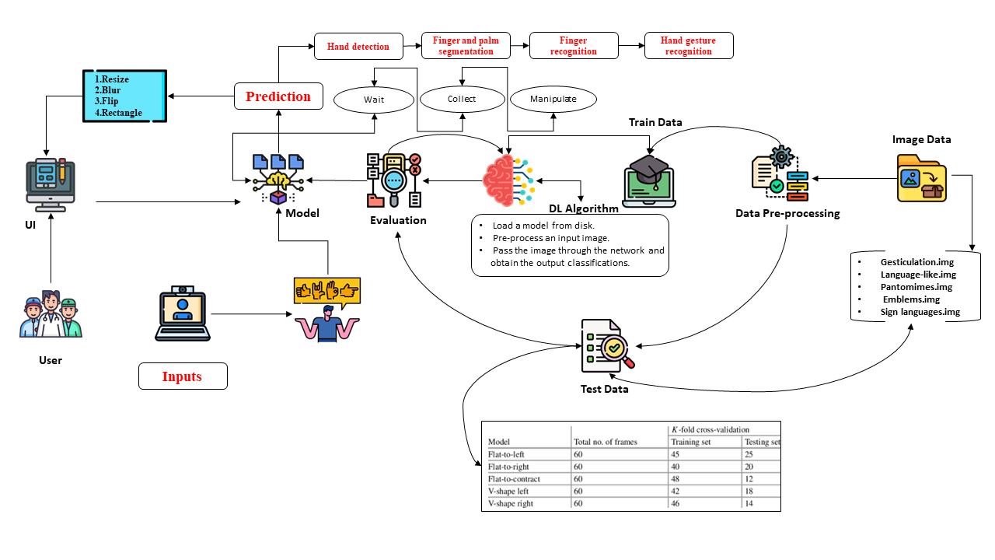

**Table-1 : Components & Technologies:**

|  |  |  |  |
| --- | --- | --- | --- |
| **S.No** | **Component** | **Description** | **Technology** |
|  | User Interface | Web UI | HTML, CSS, JavaScript |
|  | Application Logic-1 | Image processing and recognition | Python |
|  | Application Logic-2 | Logic for a process in the application | IBM Watson STT service |
|  | Application Logic-3 | Logic for a process in the application | IBM Watson Assistant |
|  | Database | Dataset | System |
|  | Cloud Database | Database Service on Cloud | IBM DB2, IBM Cloudant etc. |
|  | File Storage | File storage requirements | IBM Block Storage or Other Storage Service or Local Filesystem |
|  | Machine Learning Model | Purpose of Machine Learning Model | Object Recognition Model, etc. |
|  | Infrastructure (Server / Cloud) | Application Deployment on Local System / Cloud  Local Server Configuration:  Cloud Server Configuration : | Local, Cloud Foundry, Kubernetes, etc. |

**Table-2: Application Characteristics:**

| **S.No** | **Characteristics** | **Description** | **Technology** |
| --- | --- | --- | --- |
|  | Open-Source Frameworks | Flask is a micro web framework written in Python. It is classified as a microframework because it does not require tools or libraries. It has no database abstraction layer, form validation, or any other components where pre-existing third-party libraries provide common functions. | flask |